

Challock Spring Clean

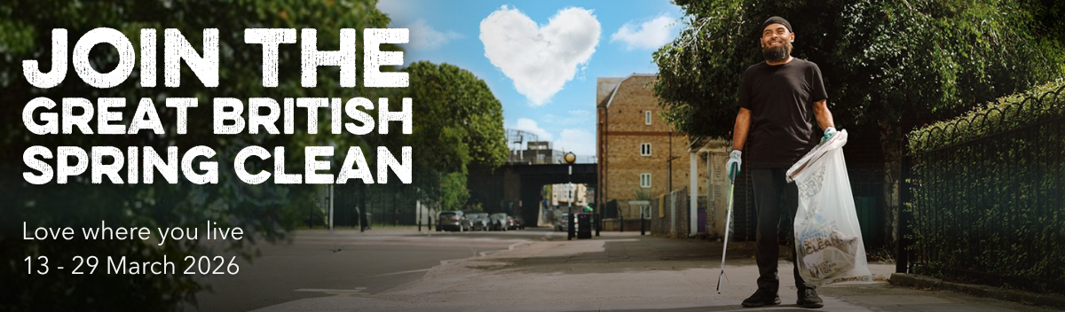
Challock Parish Council would like to organise a village litter pick for Sunday, 29th March at 10 am to meet in the village hall car park.
If you would like to join in the village litter pick on
Sunday, 29th March please email the Clerk
Di Sandy parishclerkchallockpc@gmail.com Or telephone 07895494851
All equipment & Refreshments will be provided.

