




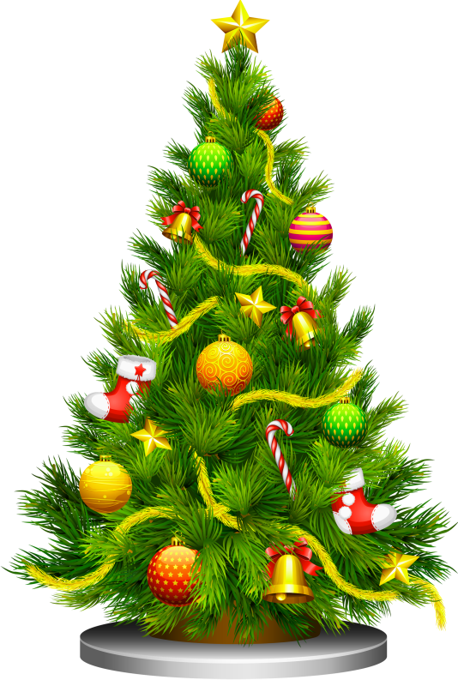
The Friends of Challock Church
Welcome All to an Afternoon of Festive Music !
CHRISTMAS CAROLS & SEASONAL SONGS
Featuring : Harpist & Pianist Emma White, The Challock Lady Singers and with supporting Challock soloist Perla Hardie
2pm for 2.30pm start
Saturday 13th December 2025
Entry....By donation only…boxes available for your generous contributions to the Church Maintenance Fund
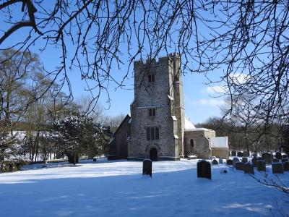
Church of St Cosmas & St Damian, Church Lane Challock
Free Refreshments & Mulled Wine at the interval
Plus a Raffle
ALL ARE WELCOME !!!!

