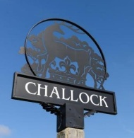

**The**

**Forester**

Invitation to Tender

**Forester Editorial 2026**

**Challock and Molash Parish Council are seeking bids from budding Editors for the Forester Editorial**

**A Community Magazine run by Challock and Molash Parish Councils.**

**As the Forester is public funded, we are looking to considerably reduce the £2,000 per annum fee we currently pay. This does NOT include the printing costs; we are inviting bids for the editorial preparation of the magazine to print ready artwork.**

**The magazine to include articles of local history, about local people, local events and local businesses, plus the standing advertisements. You will get assistance and support from the Council’s team.**

**Sealed bids marked Forester Editorial will be received at The Barn Shop, Challock up to 4 pm on Friday, 14th November 2025**

**Enquiries can be submitted by email:** [**parishclerkchallockpc@gmail.com**](mailto:parishclerkchallockpc@gmail.com)