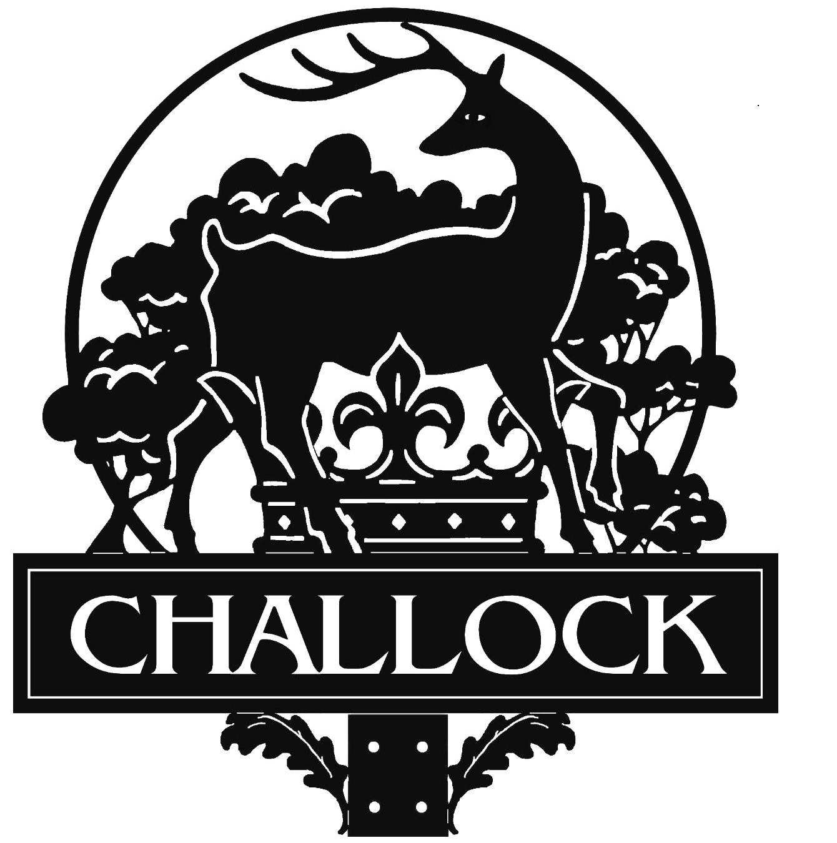

Annual Parish Meeting
Challock Memorial Hall
Tuesday, 20th May 2025 at 7.30pm

Agenda

Welcome & Introductions
Apologies for absence
Minutes of the Annual Parish Meeting 21st May 2024
KCC Ward Councillor Jeremy Eustace
Chairperson’s Report
Volunteer Presentations
Open Forum for Community Groups & Clubs
Parish Forum
Refreshments

