Challock Spring Clean
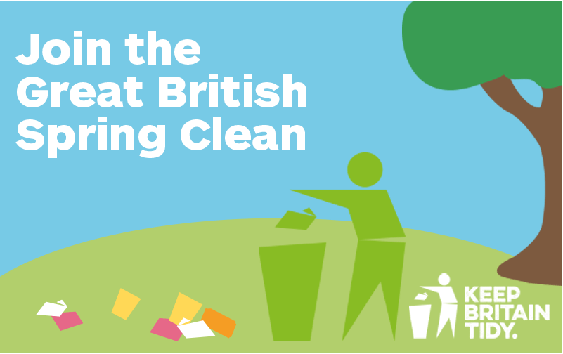

Challock Parish Council would like to organise a village litter pick for Sunday, 14th April at 10 am to meet in the village hall car park.
If you would like to join in the village litter pick on Sunday, 14th April please email the Clerk Di Sandy parishclerkchallockpc@gmail.com
Or telephone 07895494851
All equipment & Refreshments will be provided.

