Challock Spring Clean
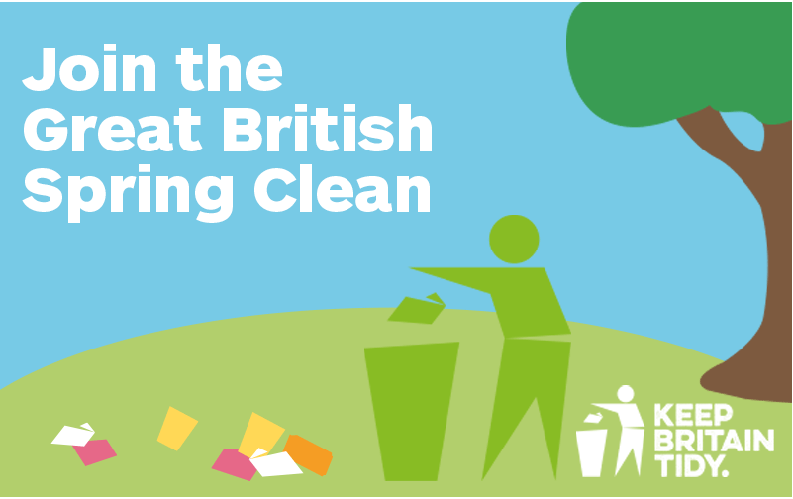

Challock Parish Council would like to organise a village litter pick for Sunday, 2nd April at 10 am to meet in the village hall car park.
If you would like to join in the village litter pick on Sunday, 2nd April please email the Clerk Di Sandy parishclerkchallockpc@gmail.com
Or telephone 07895494851
All equipment & Refreshments will be provided.
Crossroad Motors kindly donating a bottle of wine and sweets for volunteers who participate.

