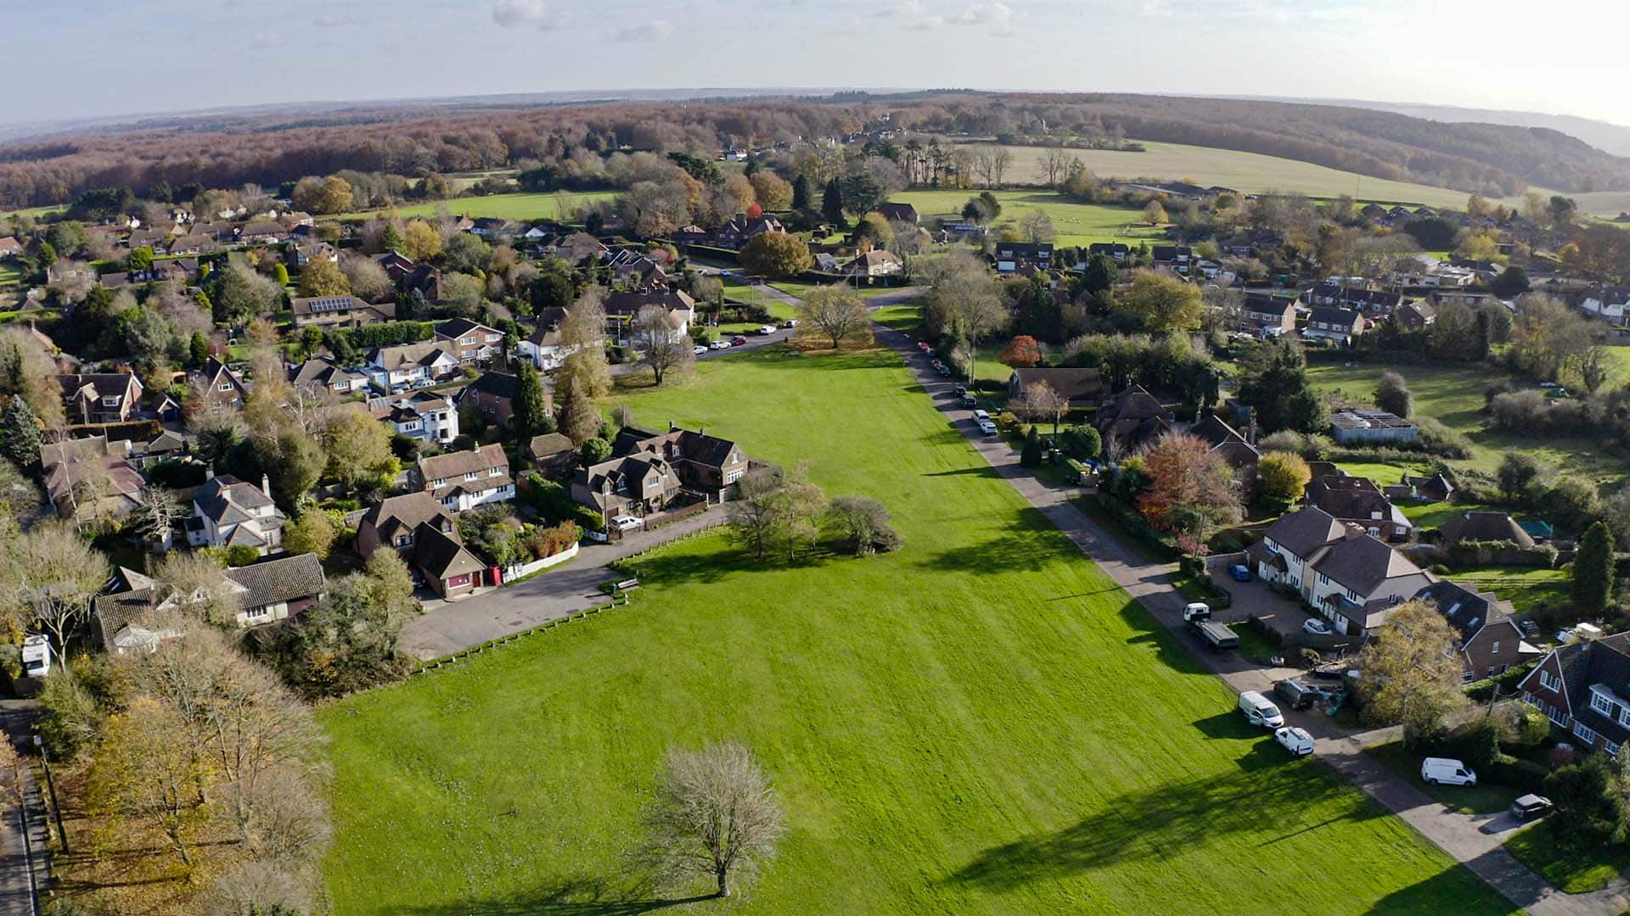
Challock Boot Fair
Challock Lees
Sunday, 1st May
No Booking - Cars £10, Cars with Trailers & Vans £15
Free Parking
Open for Sellers 7am
Proceeds in Aid of Jubilee Celebrations & Faversham Road Footpath.
Collection for Ukraine Emergency Red Cross.
Challock Parish Council 07895494851

